**Lab Practical #03:**

Study of different types of network cables & connectors and crimping a LAN.

**Practical Assignment #03:**

1. List various networks cable. Also, write short description.
2. Difference between guided and unguided media.
3. Give cross-wired cable and straight through cable diagram (Color Code wise).

## List various networks cable and connectors. Also, write short description.

1. **Twisted Pair Cable:** 
   * **Description**: This cable has pairs of wires twisted together. It is commonly used in homes and offices.
   * **Types**:
   1. **Unshielded Twisted Pair (UTP)**: Most common, used in LAN.
   2. **Shielded Twisted Pair (STP)**: Has extra protection from noise.
   * 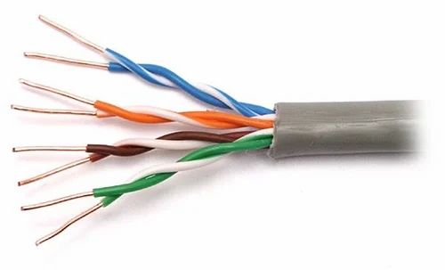**Diagram**:
2. **Coaxial Cable:** 
   * **Description**: Has a single copper wire in the center, with layers for protection. It is used for cable TV and internet.
   * **Example Use**: TV cable connection
   * 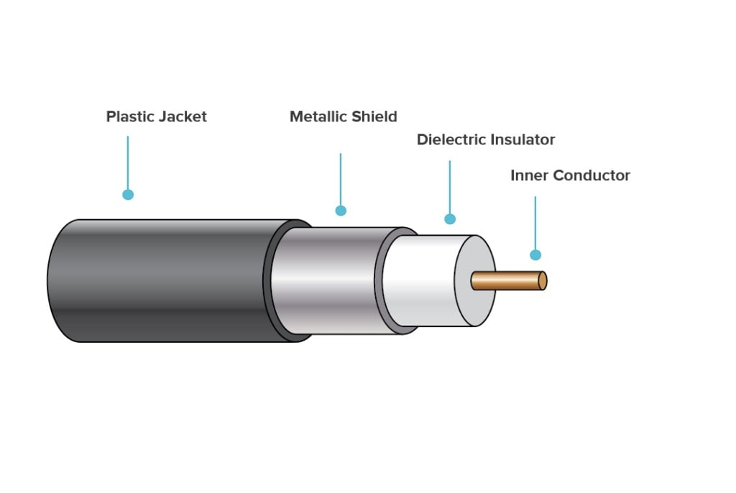**Diagram**:
3. **Fiber Option cable:** 
   * **Description**: uses light to transfer data. It is very fast and can send data over long distances.
   * **Example use**: Internet backbone, high-speed networks.
   * **Diagram**:

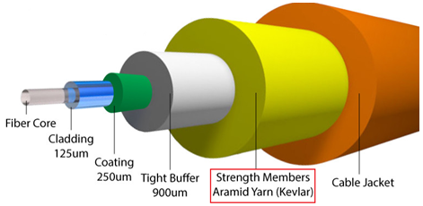

1. **Difference between guided and unguided media.**

|  |  |  |
| --- | --- | --- |
| Point | Guided Media (Wired) | Unguided Media (Wireless) |
| meaning | Uses wires or cables to send data | Sends data through air |
| Other Name | Wired media | Wireless media |
| Used medium | Cable or wire | Air or space |
| Speed | Usually fast and stable | Usually slower, can vary with distance |
| Cost | More costly | Less Safe |
| Mobility | Less movement | Easy to move devices |
| Used medium | Cable or wire | Air or space |
| Security | More Secure | Less Secure |
| examples | LAN with Ethernet, USB | Wi-Fi, Bluetooth, Mobile networks |

## Give cross-wired cable and straight through cable diagram (Color Code wise).

1. Cross-wired Cable Diagram (Color Code)

|  |  |  |
| --- | --- | --- |
| **Pin No** | **T568A (End A)** | **T568B (End B)** |
| 1 | Green-White | Orange-White |
| 2 | Green | Orange |
| 3 | Orange-White | Green-White |
| 4 | Blue | Blue |
| 5 | Blue-White | Blue-White |
| 6 | Orange | Green |
| 7 | Brown-White | Brown-White |
| 8 | Brown | Brown |

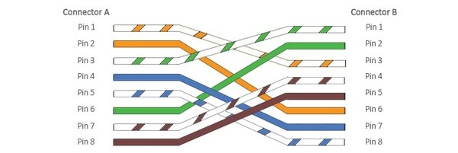

1. Straight Through Cable Diagram (Color Code)

|  |  |
| --- | --- |
| **Pin No** | **Wire Color** |
| 1 | Orange-White |
| 2 | Orange |
| 3 | Green-White |
| 4 | Blue |
| 5 | Blue-White |
| 6 | Green |
| 7 | Brown-White |
| 8 | Brown |

